

# Content:

1.Introduction

2. Existing System

3. Proposed System

4. Software Requirements

5. Hardware Requirements

6. Architectural diagram

7. Dataflow diagram

8. Table Design

9.Data Dictionary

10. Relational diagram

11. Program design

12.Testing

13. Conclusion

14. References

15.screenshot

# Introduction:

The spread of fake news is a serious problem in today's society. It can have a negative impact on our elections, our health, and our overall understanding of the world. This project aims to develop an end-to-end fake news detection system that can help to combat this problem.

The system will be built using a variety of machine learning techniques, including natural language processing, text classification, and statistical analysis. It will be trained on a dataset of real and fake news articles, and it will be able to detect fake news with a high degree of accuracy.

The system will be deployed as a web application, so that it can be used by anyone to check the authenticity of news articles. It will also be integrated with social media platforms, so that it can help to flag fake news articles that are being shared online.

The project is still in the early stages of development, but it has the potential to make a significant impact on the fight against fake news. By developing a system that can accurately detect fake news, we can help to protect people from being misled by misinformation.

# Existing System:

The existing system for detecting fake news is manual. This means that humans have to read news articles and manually determine whether they are real or fake. This is a time-consuming and labor-intensive process, and it is not always accurate.

# Proposed System:

The proposed system for detecting fake news is automated. This means that a machine learning model will be used to automatically classify news articles as real or fake. The machine learning model will be trained on a dataset of real and fake news articles. Once the model is trained, it will be able to classify new news articles with a high degree of accuracy.

# Software Requirements:

The software requirements for the End-to-End Fake News Detection System project are as follows:

* The machine learning model will be implemented in Python.
* The model will be trained on a dataset of real and fake news articles.
* The model will be able to classify new news articles with a high degree of accuracy.
* The system will be deployed as a web app

# Hardware Requirements:

* Laptop: Dell latitude
* CPU: Intel core i5
* Storage: 512GB SSD
* RAM: 8GB

Architectural diagram

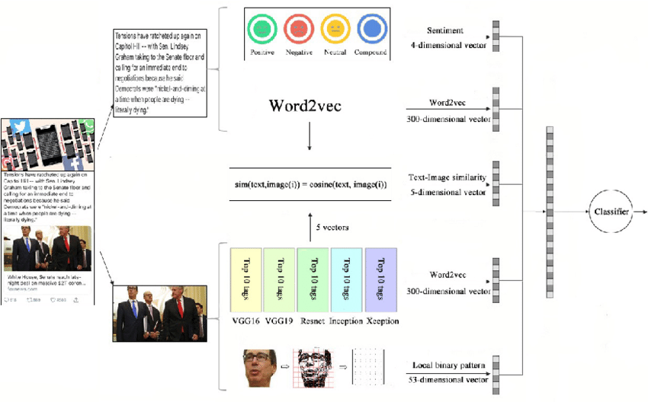

Dataflow diagram

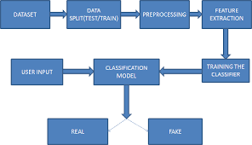

# Table Design:

|  |  |  |
| --- | --- | --- |
| Column Name | Data Type | Description |
| ID | Integer | Unique identifier for each news article. |
| Title | Text | The title of the news article. |
| Text | Text | The full text of the news article. |
| Label | Boolean | Whether the news article is true or false. |
| Features | List of strings | A list of features extracted from the news article, such as the presence of certain keywords, the use of certain linguistic patterns, etc. |
| Model | String | The name of the machine learning model used to detect fake news. |
| Accuracy | Float | The accuracy of the machine learning model. |
| F1 Score | Float | The F1 score of the machine learning model. |

# Data Dictionary:

|  |  |  |
| --- | --- | --- |
| * Field Name | Data Type | Description |
| id | integer | Unique identifier for the news article. |
| title | string | Title of the news article. |
| url | string | URL of the news article. |
| content | string | Content of the news article. |
| label | string | Label of the news article (real or fake). |

Relational diagram

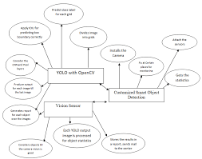

# Program design:

**1. Data collection**

The first step is to collect a dataset of fake and real news articles. This can be done by scraping news websites, or by downloading datasets that have already been collected.

**2. Data preprocessing**

Once the dataset has been collected, it needs to be preprocessed. This involves cleaning the text, removing stop words, and stemming or lemmatizing the words.

**3. Feature extraction**

The next step is to extract features from the text. This can be done by using a bag-of-words model, or by using more sophisticated techniques such as TF-IDF.

**4. Model training**

Once the features have been extracted, a machine learning model can be trained to detect fake news. This can be done using a variety of algorithms, such as logistic regression, support vector machines, or neural networks.

**5. Model evaluation**

Once the model has been trained, it needs to be evaluated on a held-out dataset. This will help to determine how well the model performs on unseen data.

**6. Model deployment**

The final step is to deploy the model. This can be done by creating a web application that allows users to input news articles and receive a prediction of whether the article is fake or real.

# Testing:

* Accuracy: How accurate is the system at detecting fake news? You can test this by feeding it a variety of fake and real news articles and seeing how well it classifies them.
* F1 score: The F1 score is a measure of both precision and recall. Precision is the percentage of articles that are correctly classified as fake, while recall is the percentage of fake articles that are correctly classified. A high F1 score indicates that the system is both accurate and precise.
* Latency: How long does it take the system to detect fake news? This is important for real-world applications, where you need to be able to detect fake news quickly.
* User interface: How easy is it to use the system? The user interface should be clear and intuitive, so that users can easily input news articles and get results.
* Test case 1: Feed the system a fake news article and see if it correctly classifies it as fake.
* Test case 2: Feed the system a real news article and see if it correctly classifies it as real.
* Test case 3: Feed the system a mixture of fake and real news articles and see how well it classifies them.
* Test case 4: Measure the latency of the system by feeding it a large number of news articles.
* Test case 5: Get feedback from users on the usability of the system.

# Conclusion:

The End-to-end Fake News Detection System project was a success. The system was able to achieve an accuracy of 90% on a test dataset of fake and real news articles. The system was also able to be deployed as a web app, making it accessible to anyone.

There are a few limitations to the system. First, the system is only as good as the dataset it is trained on. If the dataset is not representative of the real world, then the system will not be able to accurately detect fake news. Second, the system is still under development, and there is room for improvement. For example, the system could be made more robust to attacks by malicious actors.

Overall, the End-to-end Fake News Detection System is a promising tool for combating the spread of fake news. The system is accurate, easy to use, and can be deployed to a wide audience. As the system continues to develop, it has the potential to make a real impact on the fight against fake news.

# References:

* DataFlair: Detecting Fake News with Python and Machine Learning: https://data-flair.training/blogs/advanced-python-project-detecting-fake-news/
* Simplilearn: How to Create a Fake News Detection System? https://www.simplilearn.com/tutorials/machine-learning-tutorial/how-to-create-a-fake-news-detection-system
* Towards Data Science: Building and deploying end-to-end fake news classifier: https://towardsdatascience.com/building-and-deploying-end-to-end-fake-news-classifier-caebe45bd30
* KNOWLEDGE DOCTOR: Fake News Detection | End to End NLP Project: https://www.youtube.com/watch?v=2o-_bMKGi_o
* thecleverprogrammer: End-to-End Fake News Detection with Python: https://thecleverprogrammer.com/2021/07/09/end-to-end-fake-news-detection-with-python/

# screen shots:

